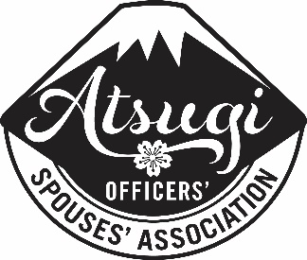
FY 2017-2018 Community Grant Request

The Atsugi Officers’ Spouses’ Association (AOSA) makes charitable funds available to private organizations serving the NAF Atsugi area. This funding is made possible by the generous volunteer efforts of our AOSA members and from profits earned from Ichiban Collectables.
All requests must be made using the following two-page 2017-2018 form. Older grant request forms will not be accepted. All requests not submitted using this form or missing information as requested may be delayed or denied.
AOSA accepts and votes on grant requests on a quarterly basis. Monthly and annual requests will no longer be accepted and will be returned to sender. Requests will only be accepted on a quarterly basis by January 15, April 15, July 15 and October 15 to be voted on by the General Membership during the following month. Any request received after close of business on Jan 15, April 15, July 15 and October 15 will not be considered that quarter.
In addition to the form below, any organization requesting a grant greater than $3000 will need to be prepared to present the grant request at an AOSA Board and/or General Meeting, if the AOSA Executive Board deems it necessary.
Requests may be submitted by mail to:

AOSA Community Grant Requests
PSC 477 BOX 344
FPO, AP 96306

Or they may be emailed to aosavp2@gmail.com. All requests will receive an email confirmation of receipt. If you do not receive email confirmation within 7 days, please write the above email address to confirm that we have received your request.

If you have any questions please feel free to contact the Community Grants Chairperson, via email at aosavp2@gmail.com.

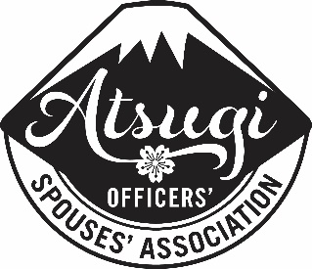
ATSUGI OFFICERS’ SPOUSES’ ASSOCIATION
FY 2017-2018 Community Grant Request

Date Submitted ____________________
Name and Address of Organization Requesting the Grant ____________________________________________________________________________________________________________________________________________________________________________________________________________________________________________________________________________________________________________________________________________________________________________________________________________________________________
Point of Contact ____________________________________________________________________________
POC Phone Number ____________________ POC Email Address _______________________________
Requesting Organizations Mission Statement (If more space is needed, please attach statement separately.)
_______________________________________________________________________________________________________________________________________________________________________________________________________________________________________________________________________________________________________________________________________________________________________________________________________________________________
Amount Requested $ __________________________ Date Required________________________ (please note that grant requests are accepted on a quarterly basis and will be distributed in the month following the due date.)
Purpose of Request (Please be as specific as possible and list breakdown of costs, if applicable.)
________________________________________________________________________________________________________________________________________________________________________________________________________________________________________________________________________________________________________________________________________________________________________________________________________________________________________________________________________________________________________________________
Total amount needed for your function/activity/item $ _______________________________________
Who in the NAF Atsugi community would benefit and how? ________________________________________________________________________________________________________________________________________________________________________________________________________________________________________________________________________________________________________________________________________________
What other fundraising has been or will be done by your group for this specific purpose? ________________________________________________________________________________________________________________________________________________________________________________________________________________________________________________________________________________________________________________________________________________
Has your organization requested funds for this or anything else from AOSA in the last fiscal year? If so how much have you requested and how much has been awarded? (AOSA’s fiscal year is Oct.1- Sept. 30)
________________________________________________________________________________________________________________________________________________________________________________________________________________________________________________________________________________________________________________________________________________
Are you requesting funds for this specific purpose from any other organizations? If so, who from and how much? (E.g. If your total amount needed is $1000, are you asking 2 groups for $500 each or for the full amount?)
____________________________________________________________________________________________________________________________________________________________________________________________________________________________________________________________

AOSA USE ONLY
Date Application Received __________________Date Approved or Denied________________(Circle)
Amount Awarded _______________ Date grant was awarded/delivered ________________
Organization Sponsor Signature of Check Acceptance
____________________________________________________________________________________

